



Quiz platform

Table of Contents

1. Topic 2

2. Authors 2

3. Summary 3

Goal 3

Main stages in accomplishment of the project: 3

Planning 3

Realization 3

Presentation 3

Level of difficulty main problems during realization: 3

Explanation of some of the code: 3

Diagram: 5

4. Explanation of functions 6

**QUIZ PLATFORM**

# Authors



Atanas Angelov Burmov

AABurmov18@codingburgas.bg



Stefan Danielov Stratev

sdstratev18@codingburgas.bg



Hussein Semir Abumelih

hsabumelih18@codingburgas.bg



Magdalena Ilianova Omayska

miomayska18@codingburgas.bg

# Topic

The topic of our project is a platform similar to the one we use in school. With “Quiz platform”, through certain profiles, users can create/take quizzes, make and manage or access profiles. You can also make changes to account information or delete accounts. With this program, we hope to make grading students easier.

# Summary

Goal - our goal was to create a useful application for creating and taking tests on different subjects.

## Main stages in accomplishment of the project:

Planning – In this stage, we thought about the idea of our project. We came up with the idea of a platform for making quizzes on different subjects and expanded it to include other features such as making, accessing and deleting accounts.

Realization – In this second step we started writing the code of our project and creating the presentation and documentation which explain everything in further detail.

Presentation – The final step is presenting the finished product in front of the judges.

## Level of difficulty main problems during realization:

The most difficult part of completing our project was writing the code for the program. Along the way we had a few misunderstandings about the functionality of different parts of the code. We also had a few mishaps with GitHub but at the end we managed to overcome everything and complete our tasks.

## Explanation of some of the code:

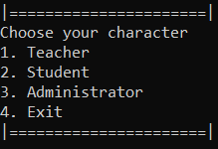

The main menu: here the user choses their role and proceeds into the program. Let’s say the user chooses option number 3

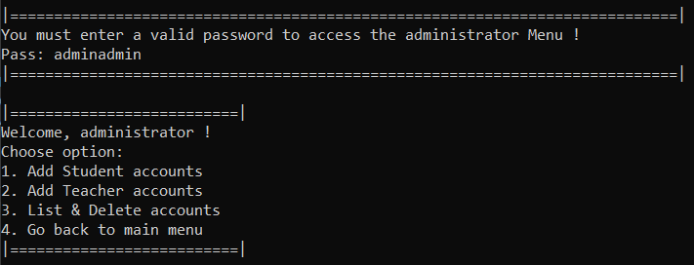

The administrator menu: once the user enters the correct password, they enter the administrator’s menu

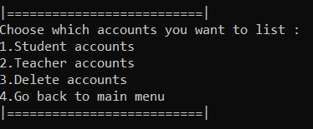

The list/delete accounts menu: when the administrator chooses the 3rd option, they are presented with the list/delete accounts menu

## Diagram:

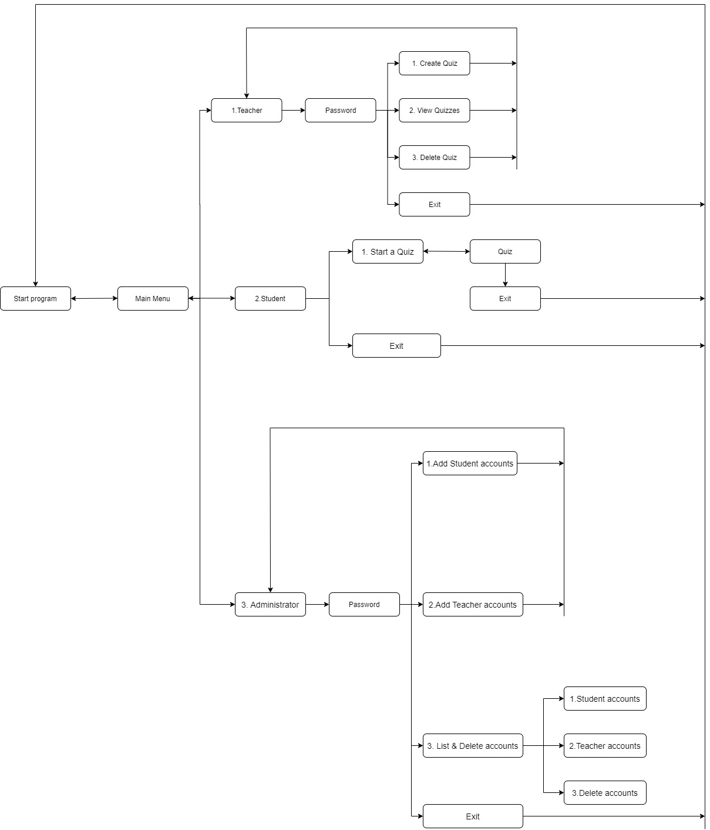

# Explanation of functions

|  |  |  |  |
| --- | --- | --- | --- |
| Function name | Arguments | Purpose | Return value |
| mainMenu | string trPasstry, string stUsernameTry, string stpasstry, string adminPass, string adminpasstry, ADMINISTRATOR* reg, int stCounter,  int trCounter,  int searchID, int& maxId, int quizcount,  QUIZ* quiz, int stanswercount,  int AnswerCounterStudent, string trUsernameTry | Serves as the main menu where the user chooses an option to proceed further into the program | bool |
| exit |  | Displays an exit message when the user exits the program | void |
| checkSystemTeacher | string trPasstry, string stUsernameTry, string stpasstry, string adminPass, string adminpasstry, ADMINISTRATOR* reg, int stCounter, int trCounter, int searchID, int& maxId, int quizcount, QUIZ* quiz, int stanswercount, int AnswerCounterStudent, string trUsernameTry | The user enters a username and a password the program checks if there is a teacher account with those parameters | bool |
| teacherMenu | QUIZ* quiz, int quizcount, int& maxId, int searchID | Serves as the menu where users with teacher accounts choose options | bool |
| createQuiz | QUIZ* quiz, int quizcount, int& maxId | The user enters how many questions a quiz has and proceeds to enter questions and answers | bool |
| viewQuiz | QUIZ* quiz, int quizcount, int& maxId | Displays all quizzes with their questions, answers and IDs | void |
| deleteQuiz | QUIZ* quiz, int quizcount, int& maxId, int searchID | Deletes a quiz | void |
| checkSystemStudent |  | The user enters a username and a password the program checks if there is a student account with those parameters | bool |
| studentMenu | QUIZ* quiz, int quizcount, int& maxId, int searchID, int stanswercount, int AnswerCounterStudent | Serves as the menu where users with student accounts choose options | bool |
| gradingScale |  | Displays the grading scale | void |
| checkStudentResult | QUIZ* quiz, int quizcount, int& maxId, int searchID, int stanswercount, int AnswerCounterStudent | Counts the student’s answers, calculates the points and displays the student’s grade | void |
| startQuiz | QUIZ* quiz, int quizcount, int& maxId, int searchID, int stanswercount | Displays the quiz’s questions and lets the user write his/her answers | void |
| findIdQuiz | QUIZ* quiz, int quizcount, int& maxId, int searchID | Finds a quiz’s id | int |
| viewQuizName | QUIZ* quiz, int quizcount, int& maxId | Displays all of the quizzes’ names and IDs | void |
| checkSystemAdministrator | string adminPass, string adminpasstry, ADMINISTRATOR* reg, int stCounter, int trCounter, int& maxId, int searchID | The user enters a username and a password the program checks if there is an administrator account with those parameters | bool |
| administratorMenu | ADMINISTRATOR* reg, int stCounter, int trCounter, int& maxId, int searchID | Serves as the menu where users with adminstrator accounts choose options | void |
| addStudentAccounts | ADMINISTRATOR* reg, int stCounter, int& maxId | Asks the user how many accounts they’d like to add and the user proceeds to add students’ usernames and passwords | void |
| addTeacherAccounts | ADMINISTRATOR* reg, int trCounter, int& maxId | Asks the user how many accounts they’d like to add and the user proceeds to add teachers’ usernames and passwords | void |
| listDeleteAccountsMenu | ADMINISTRATOR* reg, int trCounter, int& maxId, int stCounter, int searchID | A menu that lets the user choose if they want to view all student or teacher accounts or delete accounts | bool |
| viewStudentaccounts | ADMINISTRATOR* reg, int stCounter, int& maxId | Displays all student accounts | void |
| viewTeacherAccounts | ADMINISTRATOR* reg, int trCounter, int& maxId | Displays all teacher accounts | void |
| deleteAccount | ADMINISTRATOR* reg, int trCounter, int& maxId, int stCounter, int searchID | Deletes an account | void |
| findId | ADMINISTRATOR* reg, int trCounter, int& maxId, int stCounter, int searchID | Searches for an account’s ID | int |